**Supplementary file**

**METHOD**

**Identification and inclusion of studies for representativeness analyses**

The search strategy was adapted for Medline and PsyArticle databases using its specific vocabulary map, employing Mesh terms that referred to "cancer", "sleep" and "exercise". The Medline search strategy first included Mesh terms related to cancer (“Neoplasm”) AND sleep ("Sleep", "Sleep Disorders", "Sleep Initiation and Maintenance Disorders") AND exercise ("Exercise", "Physical Therapy Modalities", "Motor Activity", "Exercise Therapy", "Sports"). This algorithm was then adapted to PsyArticle database.

**Inclusion criteria**

*Participants*

Studies were included if they included adult patients only (18 years and older) with a cancer diagnosis. Participants, men and women, could have any type of cancer and could be at any stage of the cancer care trajectory (during or after treatment).

*Interventions*

Various forms of exercise interventions were considered eligible including aerobic, resistance or a combination of both. Exercise interventions could be combined with flexibility exercises or with another type of intervention (e.g., counseling). However, yoga interventions were excluded given the large heterogeneity of yoga types, being more or less demanding physically. No restriction was made regarding frequency, intensity or duration of the program. Interventions could be unsupervised or supervised.

*Comparisons*

Control arms could be usual care (no exercise intervention) or an alternative intervention (e.g., relaxation).

*Outcomes*

RCTs had to contain at least one self-reported measure of sleep disturbance (with the EORTC sleep item) or sleep quality (with the Pittsburgh Sleep Quality Inventory).

**References checked**

Mercier, J., Savard, J., & Bernard, P. (2017). Exercise interventions to improve sleep in cancer patients: A systematic review and meta-analysis. *Sleep Medicine Reviews*. https://doi.org/10.1016/j.smrv.2016.11.001

Mishra, S. I., Scherer, R. W., Snyder, C., Geigle, P. M., Berlanstein, D. R., & Topaloglu, O. (2012). Exercise interventions on health-related quality of life for people with cancer during active treatment. *Cochrane Database of Systematic Reviews*.

Tomlinson, D., Diorio, C., Beyene, J., & Sung, L. (2014). Effect of Exercise on Cancer-Related Fatigue: A Meta-analysis. *American Journal of Physical Medicine & Rehabilitation*, *93*(8), 675–686. https://doi.org/10.1097/PHM.0000000000000083

**RESULTS**

**Results from the complementary search literature**

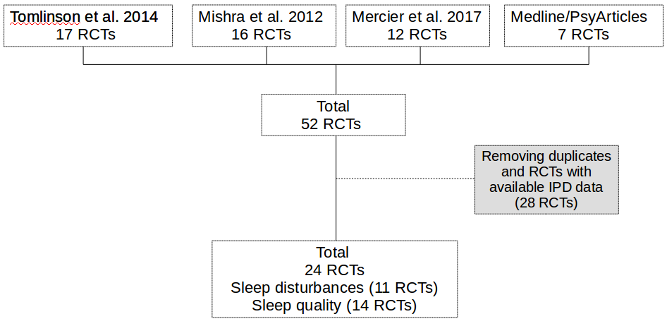

Investigations found in database published between 2016 May and 2018 November

Identified RCTs from literature searching

Brown, J. C., Damjanov, N., Courneya, K. S., Troxel, A. B., Zemel, B. S., Rickels, M. R., … Schmitz, K. H. (2018). A randomized dose-response trial of aerobic exercise and health-related quality of life in colon cancer survivors. *Psycho-Oncology*, *27*(4), 1221–1228. https://doi.org/10.1002/pon.4655

Ligibel, J. A., Giobbie-Hurder, A., Shockro, L., Campbell, N., Partridge, A. H., Tolaney, S. M., … Winer, E. P. (2016). Randomized trial of a physical activity intervention in women with metastatic breast cancer: Exercise Intervention in Metastatic Breast Cancer. *Cancer*, *122*(8), 1169–1177.

Pauli, N., Svensson, U., Karlsson, T., & Finizia, C. (2016). Exercise intervention for the treatment of trismus in head and neck cancer ? a prospective two-year follow-up study. *Acta Oncologica*, *55*(6), 686–692. https://doi.org/10.3109/0284186X.2015.1133928

Shobeiri, F., Masoumi, S. Z., Nikravesh, A., Heidari Moghadam, R., & Karami, M. (2016). The Impact of Aerobic Exercise on Quality of Life in Women with Breast Cancer: A Randomized Controlled Trial. *Journal of Research in Health Sciences*, 16(3), 127–132.

**Results from POLARIS RCTs with sleep outcomes**

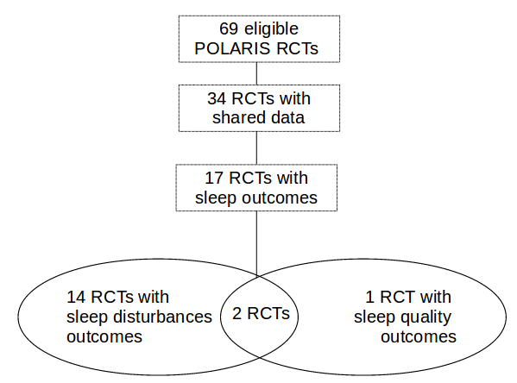

**Forest plot including all studies with sleep disturbances data**

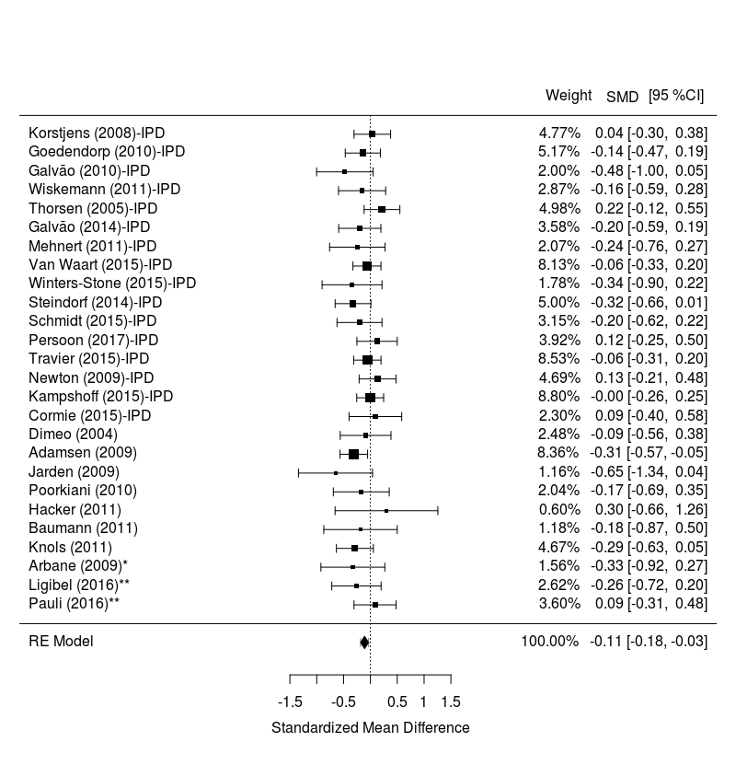

Notes. IPD = Trials with available Individual Participant Data

**Funnel plot** **including all studies with sleep disturbances data**

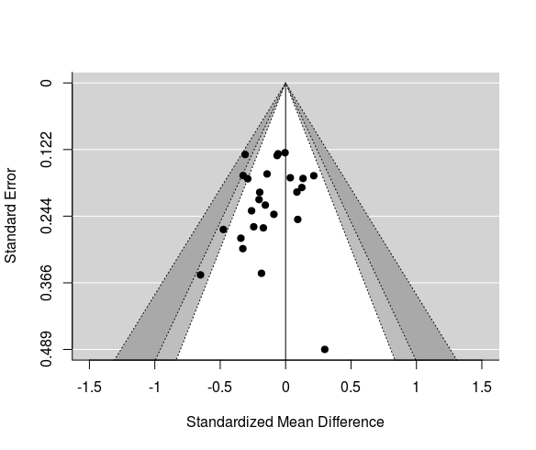

**Funnel plot** **including all studies with sleep disturbances data after the fill & trill method**

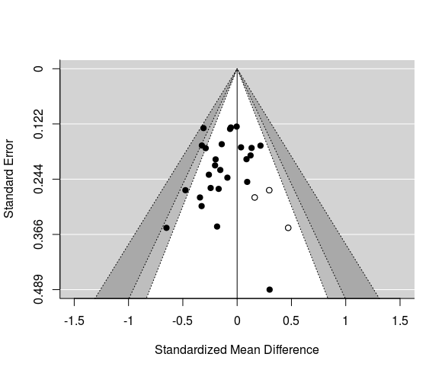

**Forest plot including all studies with sleep quality data**

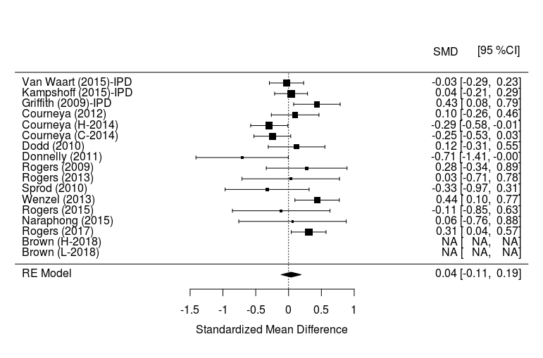

Notes. IPD = Trials with available Individual Participant Data

**Results from representativeness analyses**

**Self-reported sleep disturbances**

Forest plot for studies without IPD data, excluding one outlier

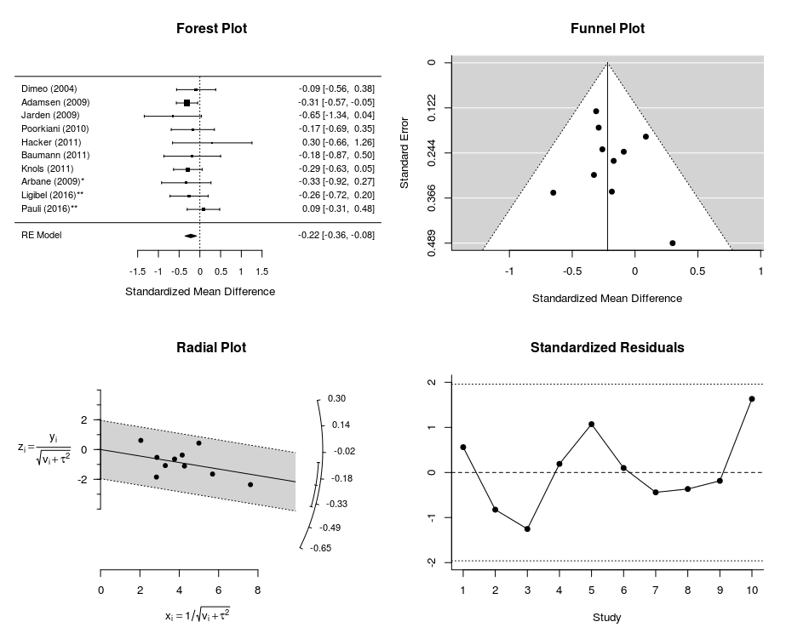

**Sleep Quality**

Forest plot for studies without IPD data, excluding two outliers

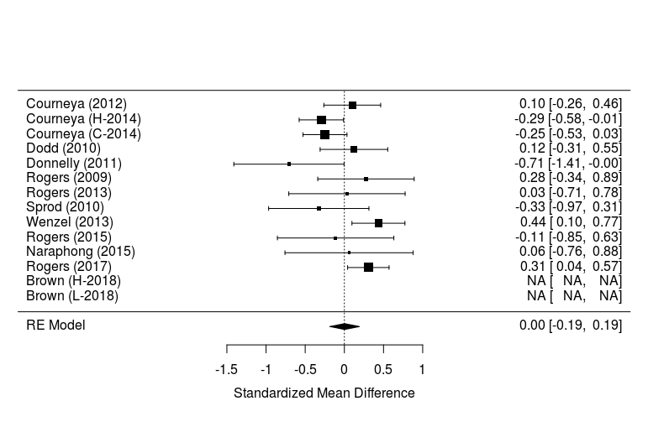

**Table S1**

Descriptives of studies evaluating the effects of exercise interventions on sleep disturbances and sleep quality

|  |  |  |  |  |  |  |  |  |  |  |  |  |  |  |  |  |  |
| --- | --- | --- | --- | --- | --- | --- | --- | --- | --- | --- | --- | --- | --- | --- | --- | --- | --- |
| **Author (year)**  ***Acronym*** | **Country** | **N** | **Age, mean (SD)** | **Gender**  **(% female)** | **Diagnosis** | **Timing** | **Delivery mode** | **Duration**  **(weeks)** | **FITT** |  | **Sleep outcomes** | **RSG** | **AC** | **IO** | **IR** | **Adh** | **Con** |
| Cormie (2015) | AUS | 64 | 67.9 (7.1) | 0 | Prostate | During ADT | Supervised | 12 | F: 2x/week  I: moderate-vigorous  T: RE+AE  T: 60 min | Usual care | S-C30 | + | + | + | **-** | ? | ? |
| Galvão (2010) | AUS | 57 | 69.8 (7.3) | 0 | Prostate | During ADT | Supervised | 12 | F: 2x/week  I: moderate  T: RE+AE  T: 60 min | Usual Care | S-C30 | + | + | + | **-** | ? | ? |
| Galvão (2014) *RADAR-exercise* | AUS | 100 | 71.7 (6.4) | 0 | Prostate | Post ADT | Supervised | 24 | F: 2x/week  I: moderate-vigorous  T: RE+AE  T: 60 min | Usual care with PA brochure | S-C30 | + | + | + | **-** | - | ? |
| Goedendorp (2010) | NL | 144 | 57.2 (10.5) | 63.2 | Mixed | During | Unsupervised | Mean: 31.7 | F: towards 5d/week  I: ?  T: AE  T: towards 60 min | Usual care | S-C30 | + | + | + | **-** | ? | ? |
| Griffith (2009) | USA | 126 | 60.2 (10.6) | 38.9 | Mixed | During CT, RT or both | Unsupervised | Mean: 12.8 | F: 5x/week  I: low-moderate  T: AE  T: 25-35min | Usual care | PSQI | ? | ? | + | **-** | - | - |
| Kampshoff (2015)  *REACT* | NL | 277 | 53.5 (11.0) | 80.1 | Mixed | Post | Supervised | 12 | F: 2x/week  I: moderate vs vigorous  T: RE+AE  T: 60 min | Wait-list | S-C30+ PSQI | + | + | + | **+** | - | + |
| Korstjens (2008)  *OncoRev* | NL | 133 | 50.6 (10.2) | 85 | Mixed | Post | Supervised | 12 | F: 2x/week  I: AE: moderate-vigorous, RE: low-moderate  T: RE+AE  T: 120 min | Wait-list | S-C30 | + | ? | + | **-** | + | ? |
| Newton (2009) | AUS | 154 | 69.0 (9.0) | 0 | Prostate | During ADT | Supervised | 24 | F: 2x/week  I: moderate-vigorous  T: RE+AE vs RE+impact  T: 60 min | Wait-list | S-C30 | ‡ |  |  |  |  |  |
| Persoon (2017) | NL | 109 | 52.4 (11.2) | 36.7 | Haematological | Post SCT | Supervised | 18 | F: 2x/week  I: moderate-vigorous  T: RE+AE  T: 60 min | Usual care | S-C30 | + | + | + | **-** | + | - |
| Schmidt (2015)  *BE**ATE* | GER | 88 | 52.5 | 100 | Breast | During CT | Supervised | 12 | F: 2x/week  I: moderate-vigorous  T: RE  T: 60 min | Relaxation | S-C30 + Sleep duration | + | + | + | **+** | - | ? |
| Steindorf (2014)  *BEST* | GER | 141 | 56.3 (8.9) | 100 | Breast | During RT | Supervised | 12 | F: 2x/week  I: moderate-vigorous  T: RE  T: 60 min | Relaxation | S-C30+ Sleep duration | + | + | + | **+** | - | ? |
| Thorsen (2005) | NOR | 139 | 39.4 (8.3) | 67.1 | Mixed | Post | Unsupervised | 14 | F: 2x/week or more  I: moderate-vigorous  T: RE+AE  T: 30 min or more | Usual care | S-C30 | + | + | + | **-** | + | - |
| Travier (2015); van Vulpen (2015) | NL | 237 | 50.7 (8.8) | 100 | Breast and Colon | During CT | Supervised | 18 | F: 2x/week  I: moderate-vigorous  T: RE+AE  T: 60 min | Usual care | S-C30 | + | + | + | **-** | + | ? |
| Van Waart (2015)  PACES | NL | 253 | 51.4 (9.5) | 95.7 | Breast and Colon | During CT | Unsupervised vs supervised | Mean: 15.9 | F: supervised: 2x/week; unsupervised towards 5x/week  I: supervised: moderate-vigorous  Unsupervised: moderate  T: supervised: RE+AE; unsupervised: AE  T: supervised: 60min; unsupervised: aim 30 min | Usual care | S-C30 +PSQI | + | + | + | **+** | - | ? |
| Winters-Stone (2015) | USA | 51 | 70.1 (8.6) | 0 | Prostate | During ADT | Supervised | 52 | F: 2x/wk supervised (+ 1x/week unsupervised)  I: moderate  T: RE+impact  T: 60 min | Attention control | S-C30 | ? | ? | + | **-** | + | + |
| Wiskemann (2011) | GER | 80 | 48.4 (14.4) | 31.3 | Haematological | Pre-during-post | Supervised | Median exercise:  16.4  Control: 15.7 | F: 5x/week  I: moderate-vigorous  T: RE+AE  T: AE: 20-40 min | Attention control | S-C30 | + | + | - | **-** | + | ? |

*Personal communication with authors. ‡ quality rating could not be performed because papers are not yet published.

ADT= androgen deprivation therapy; AE= Aerobic exercise training; S-C30= Sleep disturbances item from European Organization for Research and Treatment of Cancer Quality of Life Questionnaire – Core 30; PSQI = Pittsburgh Sleep Quality Inventory; CT= chemotherapy; RE= Resistance exercise training; RT= radiotherapy

*Quality assessment*: + = high quality; - = low quality; ? = unclear quality; RSG= random sequence generation; AC= allocation concealment; IO=incomplete outcome; IR= incomplete reporting; Adh= adherence; Con= contamination.

**References of the studies included in the IPD analyses**

Cormie P, Galvao DA, Spry N, Joseph D, Chee R, Taaffe DR, Chambers SK, Newton RU: Can supervised exercise prevent treatment toxicity in patients with prostate cancer initiating androgen-deprivation therapy: a randomised controlled trial. BJU Int 2015;115:256-66.

Galvao DA, Taaffe DR, Spry N, Joseph D, Newton RU: Combined resistance and aerobic exercise program reverses muscle loss in men undergoing androgen suppression therapy for prostate cancer without bone metastases: a randomized controlled trial. J Clin Oncol 2010;28:340-7.

Galvao DA, Spry N, Denham J, Taaffe DR, Cormie P, Joseph D, Lamb DS, Chambers SK, Newton RU: A multicentre year-long randomised controlled trial of exercise training targeting physical functioning in men with prostate cancer previously treated with androgen suppression and radiation from TROG 03.04 RADAR. Eur Urol 2014;65:856-64.

Goedendorp MM, Peters ME, Gielissen MF, Witjes JA, Leer JW, Verhagen CA, Bleijenberg G: Is increasing physical activity necessary to diminish fatigue during cancer treatment? Comparing cognitive behavior therapy and a brief nursing intervention with usual care in a multicenter randomized controlled trial. Oncologist 2010;15:1122-32.

Griffith K, Wenzel J, Shang J, Thompson C, Stewart K, Mock V: Impact of a walking intervention on cardiorespiratory fitness, self-reported physical function, and pain in patients undergoing treatment for solid tumors. Cancer 2009;115:4874-84.

Kampshoff CS, Chinapaw MJ, Brug J, Twisk JW, Schep G, Nijziel MR, van Mechelen W, Buffart LM: Randomized controlled trial of the effects of high intensity and low-to-moderate intensity exercise on physical fitness and fatigue in cancer survivors: results of the Resistance and Endurance exercise After ChemoTherapy (REACT) study. BMC Med 2015;13:275.

Korstjens I, May AM, van Weert E, Mesters I, Tan F, Ros WJ, Hoekstra-Weebers JE, van der Schans CP, van den Borne B: Quality of life after self-management cancer rehabilitation: a randomized controlled trial comparing physical and cognitive-behavioral training versus physical training. Psychosom Med 2008;70:422-9.

Newton RU, Taaffe DR, Spry N, Gardiner RA, Levin G, Wall B, Joseph D, Chambers SK, Galvao DA: A phase III clinical trial of exercise modalities on treatment side-effects in men receiving therapy for prostate cancer. BMC Cancer 2009;9:210.

Persoon S, Chin AMJM, Buffart LM, Liu RDK, Wijermans P, Koene HR, Minnema MC, Lugtenburg PJ, Marijt EWA, Brug J, Nollet F, Kersten MJ: Randomized controlled trial on the effects of a supervised high intensity exercise program in patients with a hematologic malignancy treated with autologous stem cell transplantation: Results from the EXIST study. PLoS One 2017;12:e0181313.

Schmidt ME, Wiskemann J, Armbrust P, Schneeweiss A, Ulrich CM, Steindorf K: Effects of resistance exercise on fatigue and quality of life in breast cancer patients undergoing adjuvant chemotherapy: A randomized controlled trial. Int J Cancer 2015;137:471-80.

Steindorf K, Wiskemann J, Ulrich CM, Schmidt ME: Effects of exercise on sleep problems in breast cancer patients receiving radiotherapy: a randomized clinical trial. Breast Cancer Res Treat 2017;162:489-499.

Thorsen L, Skovlund E, Stromme SB, Hornslien K, Dahl AA, Fossa SD: Effectiveness of physical activity on cardiorespiratory fitness and health-related quality of life in young and middle-aged cancer patients shortly after chemotherapy. J Clin Oncol 2005;23:2378-88.

Travier N, Velthuis MJ, Steins Bisschop CN, van den Buijs B, Monninkhof EM, Backx F, Los M, Erdkamp F, Bloemendal HJ, Rodenhuis C, de Roos MA, Verhaar M, ten Bokkel Huinink D, van der Wall E, Peeters PH, May AM: Effects of an 18-week exercise programme started early during breast cancer treatment: a randomised controlled trial. BMC Med 2015;13:121.

van Vulpen JK, Velthuis MJ, Steins Bisschop CN, Travier N, BJ VDB, Backx FJ, Los M, Erdkamp FL, Bloemendal HJ, Koopman M, MA DER, Verhaar MJ, Ten Bokkel-Huinink D, E VDW, Peeters PH, May AM: Effects of an Exercise Program in Colon Cancer Patients undergoing Chemotherapy. Med Sci Sports Exerc 2016;48:767-75.

Van Waart H, Stuiver MM, van Harten WH, Geleijn E, Kieffer JM, Buffart LM, de Maaker-Berkhof M, Boven E, Schrama J, Geenen MM, Meerum Terwogt JM, van Bochove A, Lustig V, van den Heiligenberg SM, Smorenburg CH, Hellendoorn-van Vreeswijk JA, Sonke GS, Aaronson NK: Effect of Low-Intensity Physical Activity and Moderate- to High-Intensity Physical Exercise During Adjuvant Chemotherapy on Physical Fitness, Fatigue, and Chemotherapy Completion Rates: Results of the PACES Randomized Clinical Trial. J Clin Oncol 2015;33:1918-27.

Winters-Stone KM, Dobek JC, Bennett JA, Dieckmann NF, Maddalozzo GF, Ryan CW, Beer TM: Resistance training reduces disability in prostate cancer survivors on androgen deprivation therapy: evidence from a randomized controlled trial. Arch Phys Med Rehabil 2015;96:7-14.

Wiskemann J, Dreger P, Schwerdtfeger R, Bondong A, Huber G, Kleindienst N, Ulrich CM, Bohus M: Effects of a partly self-administered exercise program before, during, and after allogeneic stem cell transplantation. Blood 2011;117:2604-13.